**Program:** **TO STUDY BASIC IP COMMANDS**.  
  
**1) PING**

Expt no: 3

1. **pinging AITD server using IP address.**

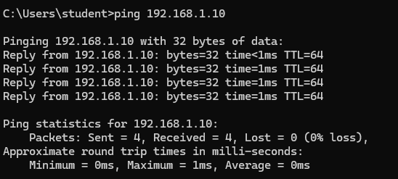

1. **pinging AITD server using domain name.**

**2) IPCONFIG**

**3) GETMAC**

**4) HOSTNAME**



**5) NSLOOKUP**

**6) TRACERT**

**a) AITD server using domain name**

**7) NETSTAT**

**8) ARP**

**9) PATHPING**

**Output:**